**Pages Managed**

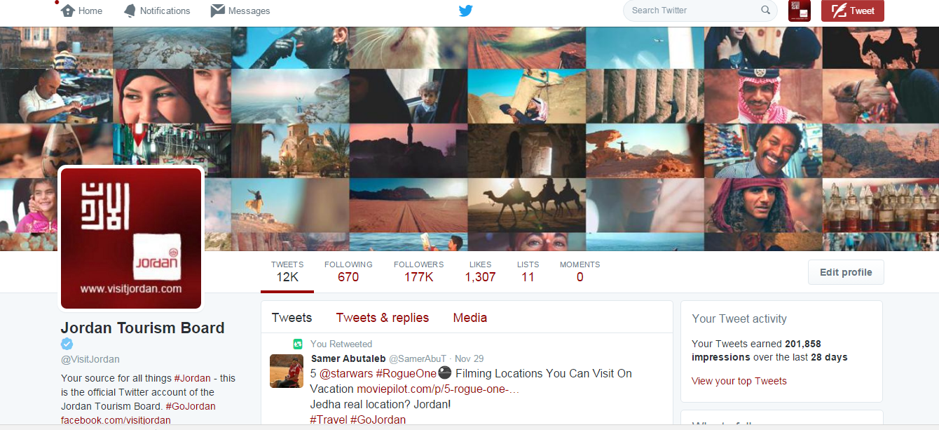

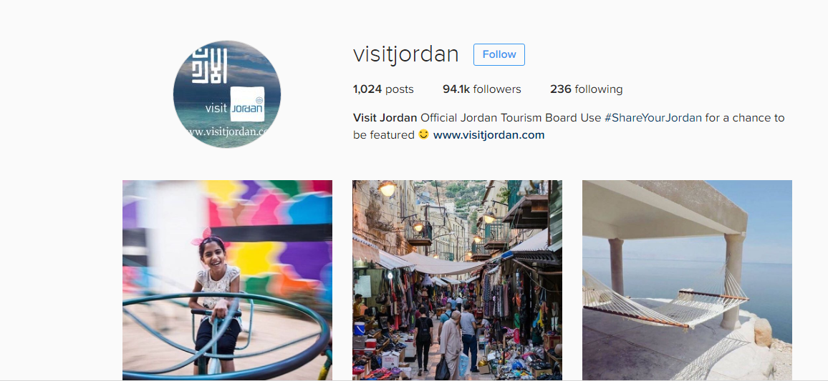

**Weekly Clips**

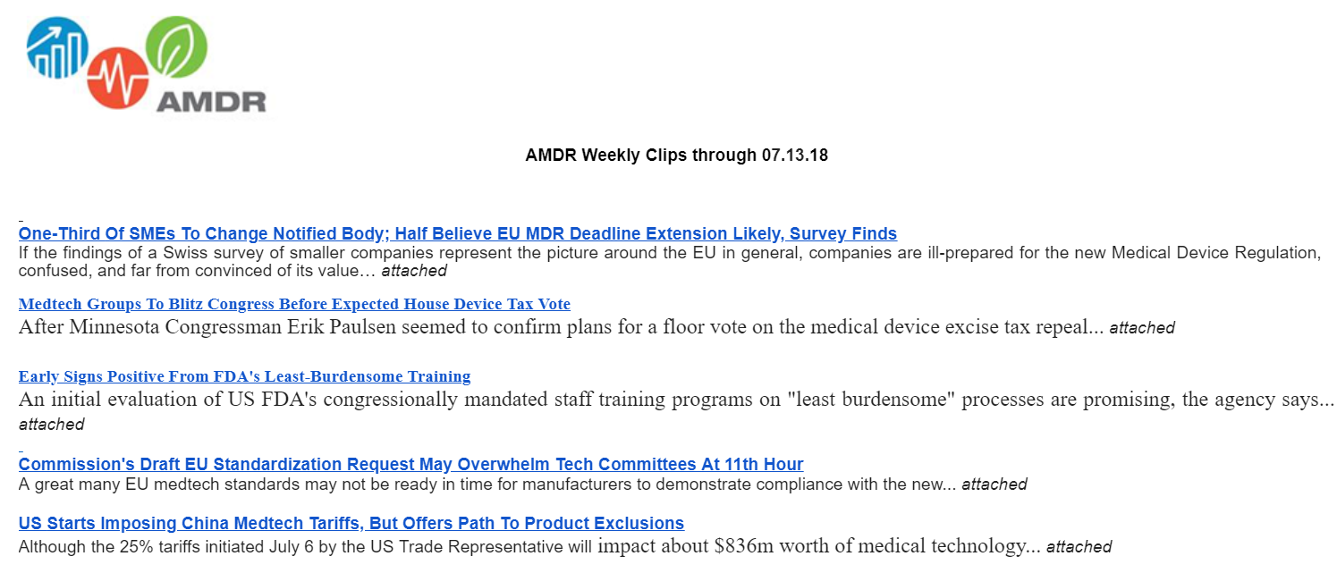

**Quarterly Newsletter:**

<https://mailchi.mp/ef1f761268a3/amdr-quarterly-newsletter-july-2018>

